vapour pressure
physics

Main
pressure exerted by a vapour when the vapour is in equilibrium with the liquid or solid form, or both, of the same substance—i.e., when conditions are such that the substance can exist in both or in all three phases. Vapour pressure is a measure of the tendency of a material to change into the gaseous or vapour state, and it increases with temperature. The temperature at which the vapour pressure at the surface of a liquid becomes equal to the pressure exerted by the surroundings is called the boiling point of the liquid.
The critical temperature, T_{c}, of a material is the temperature above which distinct liquid and gas phases do not exist. As the critical temperature is approached, the properties of the gas and liquid phases become the same resulting in only one phase: the supercritical fluid. Above the critical temperature a liquid cannot be formed by an increase in pressure, but with enough pressure a solid may be formed. The critical pressure is the vapor pressure at the critical temperature. On the diagram showing the thermodynamic properties for a given substance, the point at critical temperature and critical pressure is called the critical point of the substance. The critical molar volume is the volume of one mole of material at the critical temperature and pressure.
Critical properties vary from material to material, just as is the case for the melting point and boiling point. Critical properties for many pure substances are readily available in the literature. Obtaining critical properties for mixtures is somewhat more problematic.
Two immiscible liquids, such as oil and water, will also have a critical temperature and pressure at which the two phases will become consolute.
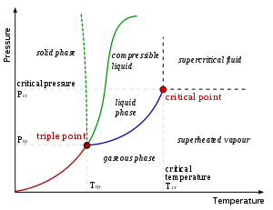
thermal conductivity, k, is the property of a material that indicates its ability to conduct heat. It appears primarily in Fourier's Law for heat conduction.
First, we define heat conduction by the formula:
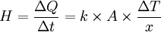
where 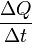is the rate of heat flow, k is the thermal conductivity, A is the total cross sectional area of conducting surface, ΔT is temperature difference and x is the thickness of conducting surface separating the 2 temperatures.
Thus, rearranging the equation gives thermal conductivity,
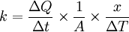
(Note: is the temperature gradient)
In other words, it is defined as the quantity of heat, ΔQ, transmitted during time Δt through a thickness x, in a direction normal to a surface of area A, due to a temperature difference ΔT, under steady state conditions and when the heat transfer is dependent only on the temperature gradient.
Alternatively, it can be thought of as a flux of heat (energy per unit area per unit time) divided by a temperature gradient (temperature difference per unit length)
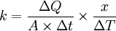
Typical units are SI: W/(m·K) and English units: Btu/(hr·ft·°F). To convert between the two, use the relation 1 Btu/(hr·ft·°F) = 1.730735 W/(m·K).
